Whitney Hardy
Task 3.8 Performing Subqueries

- Find the average amount paid by the top 5 customers.
  - The average amount paid by the top 5 costumers in the Rockbuster database is $120.32.
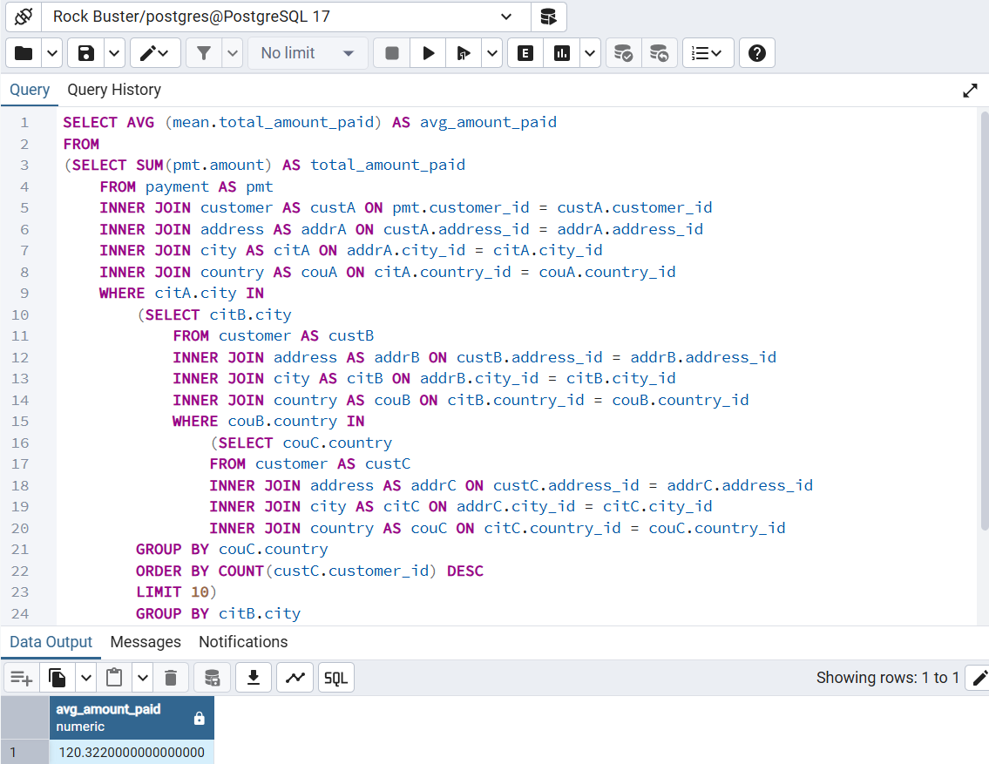
- Find out how many of the top 5 customers you identified in step 1 are based within each country.
  - Of the top 5 customers, there is one located in in the five following countries: China, United States, Mexico, Turkey, and Indonesia.
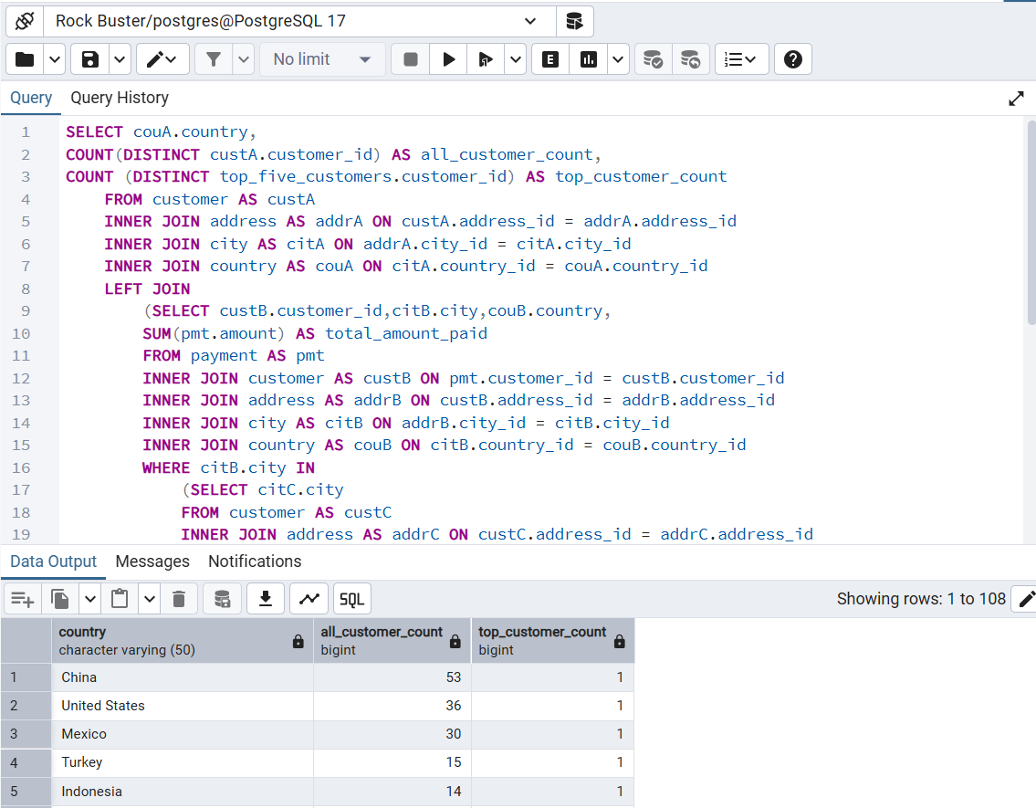
- Write 1 to 2 short paragraphs on the following:
  - Do you think steps 1 and 2 could be done without using subqueries?
Yes, it is possible to complete steps one and two without the use of subqueries. However, subqueries in this instance are the most efficient way to gather the information needed. As discussed in the reading, subqueries are very useful when working with changing data, such as top five customers. Using subqueries for both of the steps in this task also helps to reduce human error from occurring.
  - When do you think subqueries are useful?
I do believe subqueries are useful. Although they should be used only when absolutely necessary. Since subqueries are the number on cause of slow queries, they should be used sparingly. However, for instance when you are using data that is constantly changing, they can save an analyst time and help prevent human error.

